|  |  |
| --- | --- |
|  | **FPT ACADEMY INTERNATIONAL**  **FPT – APTECH COMPUTER EDUCATION** |

**Centre Name: ACE-HCMC-2-FPT.**

**Address: 590 Cach Mang Thang 8, District 3, Ho Chi Minh City, Viet Nam.**

**COSY AIR CONDITIONER**

|  |  |  |
| --- | --- | --- |
| **Supervisor:** | Phạm Thị Lánh | |
| **Term:** | 1 | |
| **Batch No:** | T1.2112.EO | |
| **Group No:** | Group 5 | |
| **Order:** | **Full name** | **Roll No.** |
| 1. | Huỳnh Thanh Tú | Student1357831 |
| 2. | Nguyễn Ngọc Trúc Anh | Student1352282 |
| 3. | Nguyễn Hoàng Chương | Student1357875 |
| 4. |  |  |
| 5. |  |  |

March 2022

**CONTENT**

1. Content 2
2. Acknowledge 3
3. Synposis 4
4. Problem definition 5
5. Customer requirement specifications 7
6. Architecture and design of the project 9

1. Sitemap 10
2. Review 1 11
   1. Screenshots 12
      1. Homepage 12
      2. Product 14
      3. Product detail 15
      4. Product comparison 16
      5. About us 17
      6. Contact us 18
      7. Blog 19
3. Tasksheet 20
4. Review 2 21
   1. Screenshots 22
      1. Homepage 22
      2. Product 26
      3. Product detail 28
      4. Product comparison 31
      5. About us 32
      6. Contact us 35
      7. Blog 36
5. Tasksheet 37
6. Testting Document 39
7. Final Checklist 40

The eProject, as we understand it, is a step-by-step learning environment that closely simulates the classroom and lab-based learning spaces into actual implementation. It's a project implementation, a live electronic junction on the machine that allows learners to:

**ACKNOWLEDGEMENT**

* Practice step by step.
* Build a larger more robust application.
* Usage of certain utilities in applications designed by user.
* Single program to unified code leading to a complete application.
* Learn implementation of concepts in a phased manner.
* Enhance skills and add value.
* Work on real life projects.
* Give a real-life scenario and help to create applications more complicated and useful.
* Mentoring through email support.

We would like to express our heartfelt gratitude to our professor and other students for their invaluable assistance throughout the project.

Aside from the mistakes we made in the project, we hope to have more opportunities to broaden our knowledge in the web development.

We also appreciate your information and the "demo" project from India APTECH, which will allow us to gain more real-world experience in this project. Since we have gained more experience from this project, we will continue to learn as much as we can in order to be more successful in the future.

Yours sincerely,

Group 5

This program's goal is to provide a sample project for working on real-world projects. This project involves the development of a website for a company that sells air conditioners.

**SYNOPSIS**

This project is for students who have finished the HTML5 module.

This website was created to meet the needs of a company that sells air conditioners. We provide many special features on this website, such as product comparison, add to cart, and so on.COSY AIRCONDITIONERS is selling various types of AIR CONDITIONERS. The company advertises by distributing the pamphlets, advertising on television and so on. Due to rapid development in internet field, the company decides to launch a website where people will get all the information about the various products available with them easily.

**PROBLEM DEFINITION**

You are supposed to create a website for them with the below mentioned requirement specifications.

The website is to be developed for the Windows Platform using HTML5, JavaScript and Geolocation. The site should work well in all leading browsers including Chrome, IE, Firefox etc.

Requirement Specification:

The Web site is to be created based on the following requirements.

1) The Home Page should be created making use of Sections with a suitable logo.

2) Home Page should contain details of Air Conditioners with suitable images.

3) The site should display a menu which will contain the options for brief introduction about the various air conditioners available, location of the shop and any other information if required.

4) The information should be categorized according to the brand names of the products like if a User wants to see only “WHIRLPOOL” products or any other companies products then he/she can click on a Link/button/menu etc and can see only that Brand products.

5) When a user selects any particular brand, a list of products for that brand will be displayed

6) A brief summary of features of individual products should be displayed on the Web Page along with the product but detailed Features should be stored in Individual Word documents which can be downloaded or viewed by the User who wishes to see the same.

7) The user should also be able to compare the various products of different as well as similar brands.

8) There should be a “Contact Us” page which will have the Address of the Company which is as follows and the mail address which when clicked will invoke the local mail client from where they can send an email. Address of the Company should be displayed using GeoLocation API (eg. GoogleMaps).

**CUSTOMER REQUIREMENTS SPECIFICATIONS**

|  |
| --- |
| **User** |
| **Input:**   * Input consumer’s address of residence or office * Send questions/requests to the company |
| **Process:**   * Process consumer’s address data * Collect questions/requests sent by consumers |
| **Output:**   * Show the store address to consumers * Reply to the consumer’s requests/questions. |

|  |
| --- |
| **Web Master:** |
| **Input:**   * Control website database, input product information, etc. |
| **Process:**   * Analyze website |
| Output:   * Website interface, images, forms, etc. * Giving interaction |

|  |
| --- |
| **Hardware / Software Requirement:** |
| **Software:**   * Notepad/HTML editor * Dreamweaver/Javascript |
| **Hardware:**   * A minimum computer system that will help you access all the tools in the courses is a Pentium 166 or better * 64 Megabytes of RAM or better |

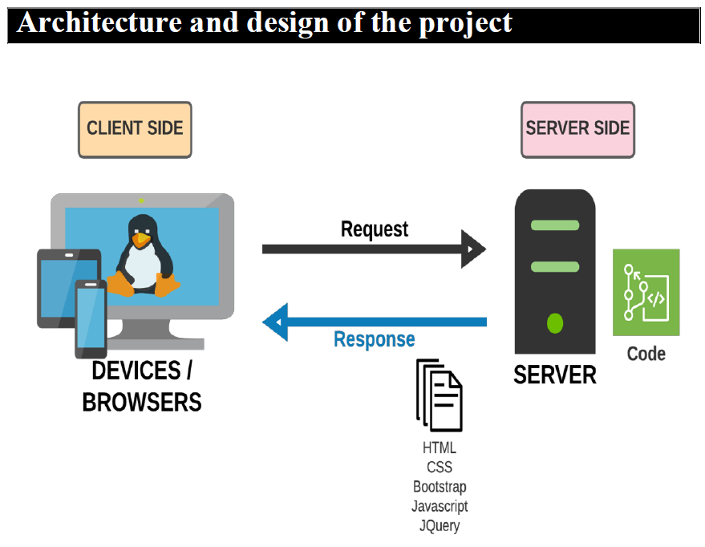

**ARCHITECTURE AND DESIGN OF THE PROJECT**

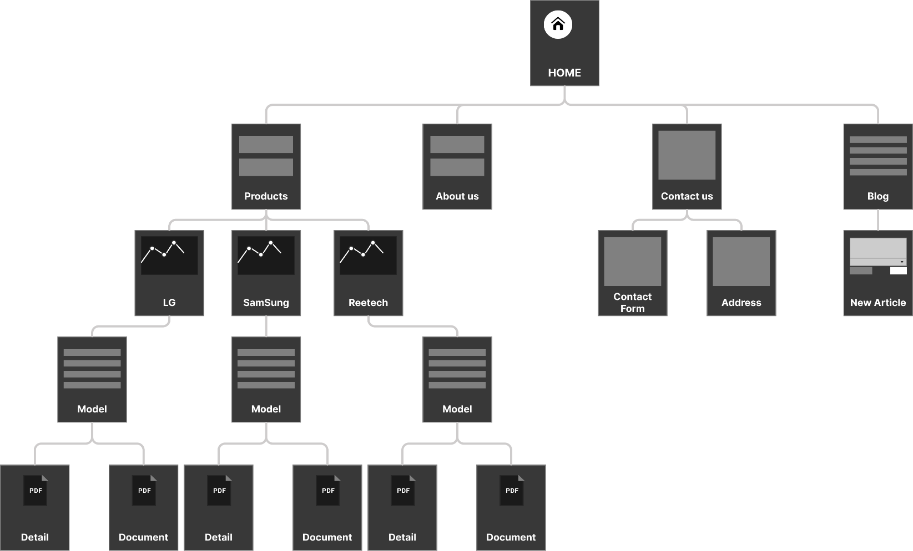

**SITEMAP**

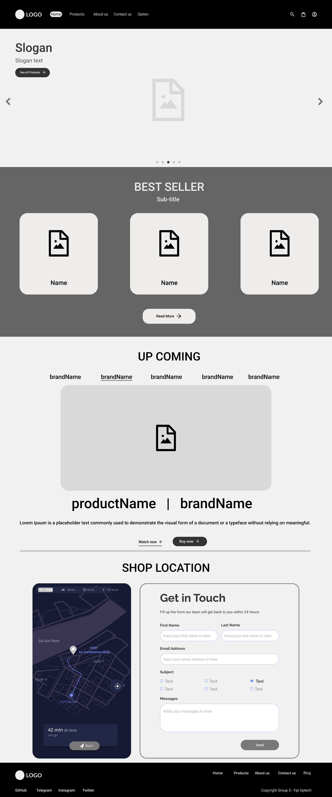**I.** **Homepage**

**REVIEW 1**

**SCREENSHOTS**

****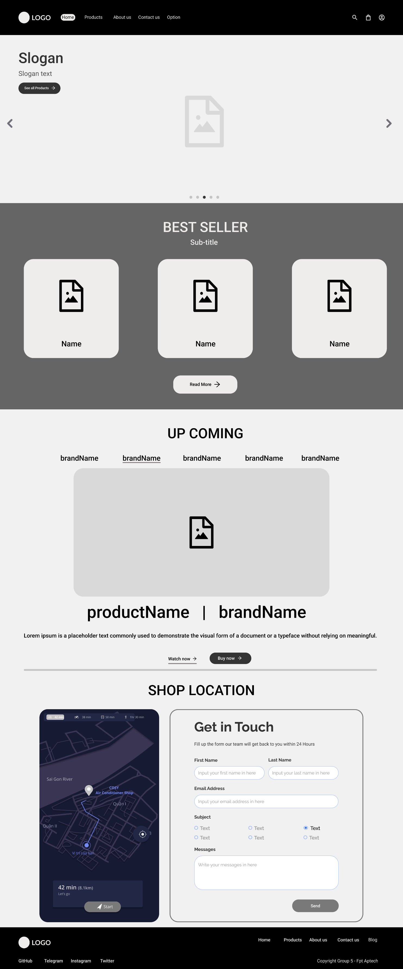

1. 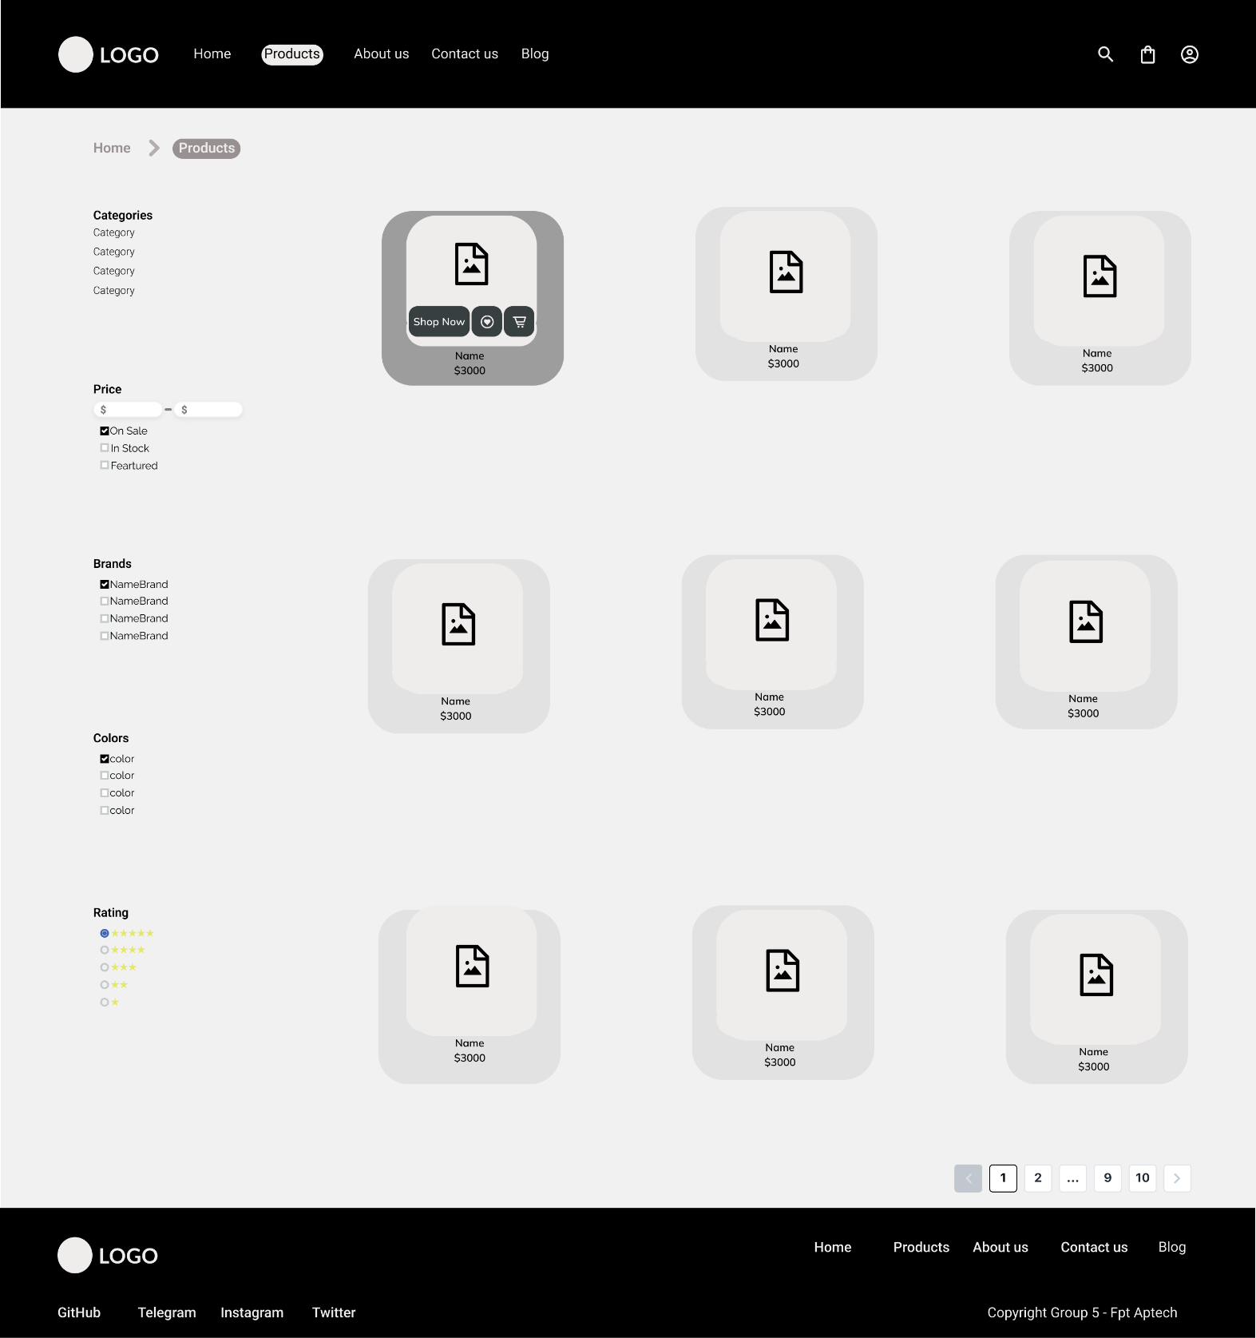**Products**
2. 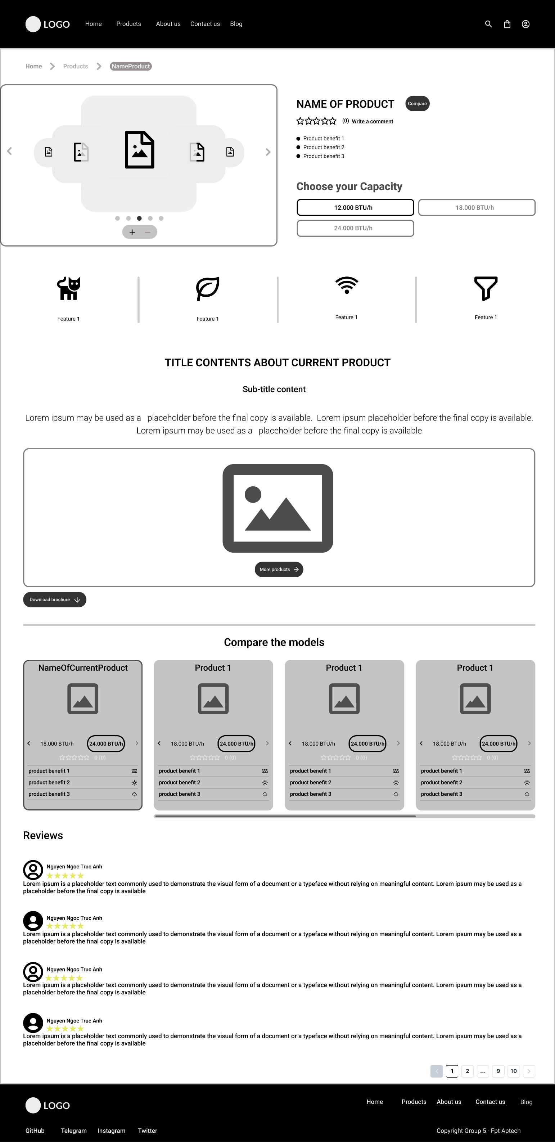**Product details**
3. 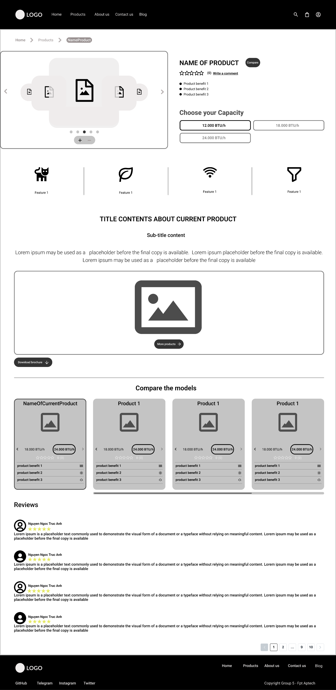**Product comparation**
4. 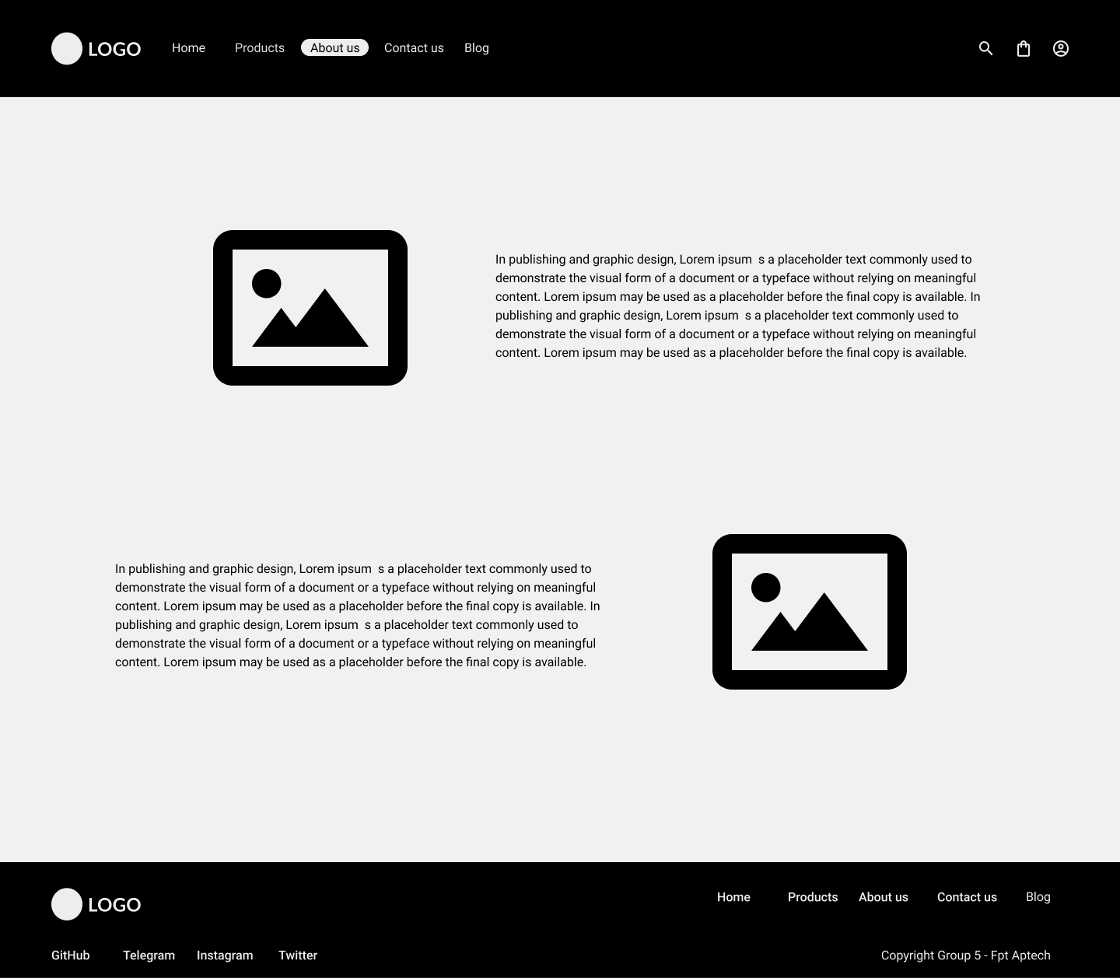**About us**
5. 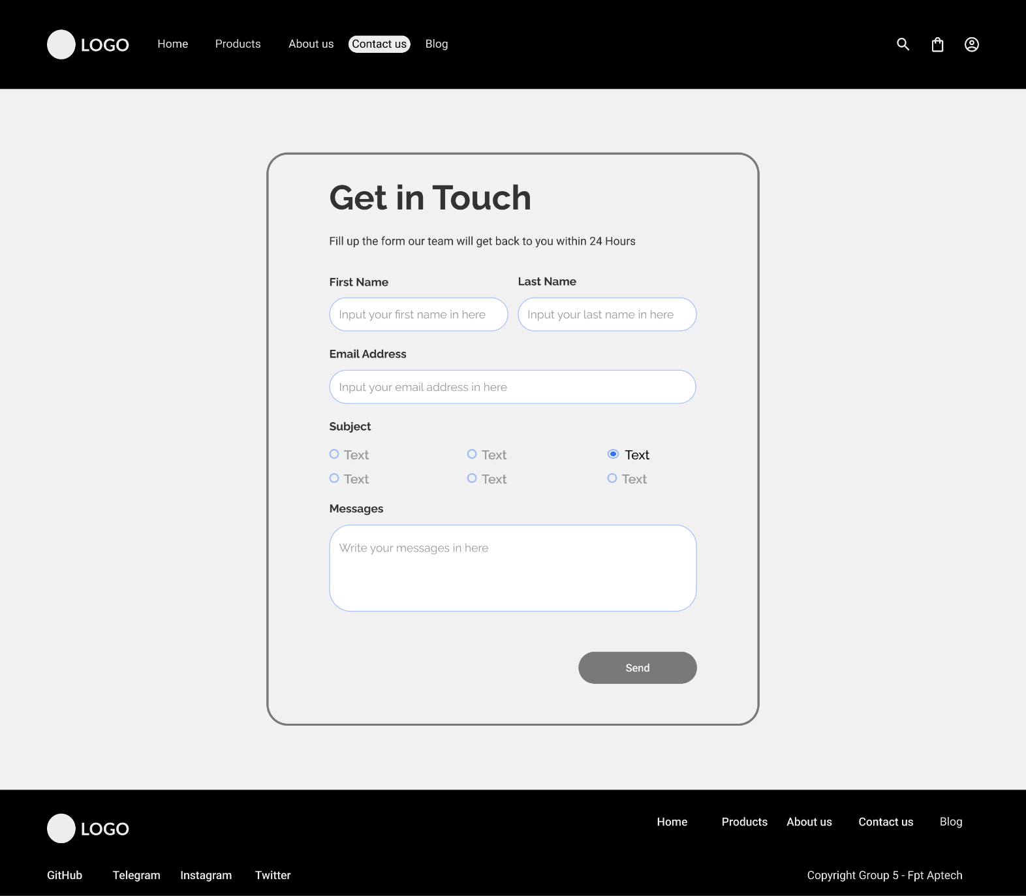**Contact us**
6. **Blog**

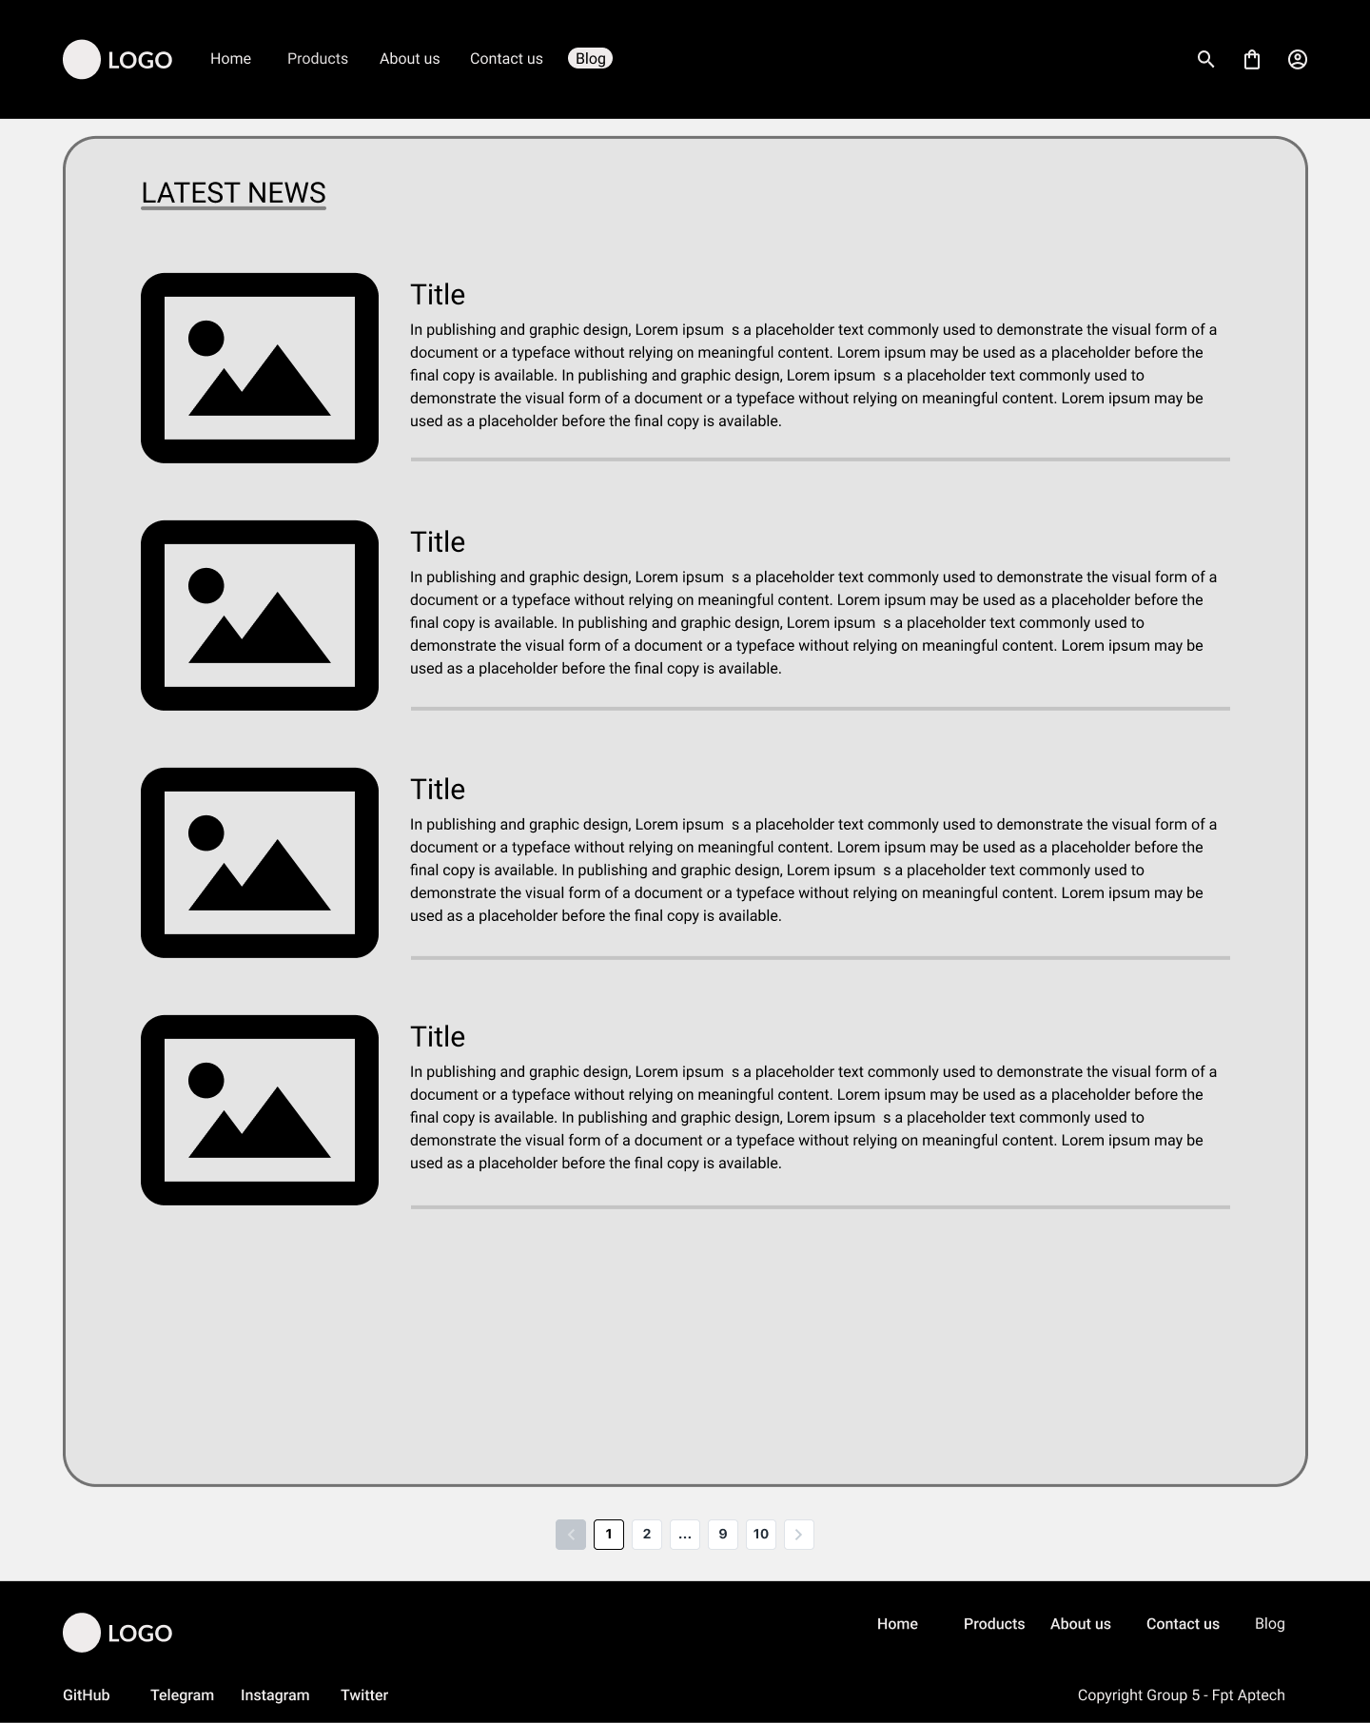

**REVIEW 1 – TASK SHEET**

|  |  |  |  |  |  |  |
| --- | --- | --- | --- | --- | --- | --- |
| **Project Ref No.** | **Project title –**  **COSY Air-conditioner** | **Activity Plan Prepared by** | **Date of preparation of Activity plan** | | | |
| **Task** | **Actual Start Date** | **Actual Days** | **Teammate Name** | **Status** |
| |  | | --- | | Brainstorming ideas for layouts and Project Object | | | Thanh Tú, Hoàng Chương, Trúc Anh | 30/3/2022 | 2 days | Thanh Tú, Hoàng Chương, Trúc Anh | Completed |
| |  | | --- | | Draw site maps and architecture design | | | Thanh Tú, Trúc Anh | 1/4/2022 | 1 days | Thanh Tú, Hoàng Chương, Trúc Anh | Completed |
| |  | | --- | | Wire framing general page layout | | | Thanh Tú, Hoàng Chương | 2/4/2022 | 1 days | Thanh Tú, Hoàng Chương, Trúc Anh | Completed |
| |  | | --- | | Collect static assets (pictures, mp4, documentation, etc.) | | | Thanh Tú, Hoàng Chương, Trúc Anh | 3/4/2022 | 1 days | Thanh Tú, Hoàng Chương, Trúc Anh | Completed |

**RE****VIEW 2**

**SCREENSHOTS**

1. **Homepage**

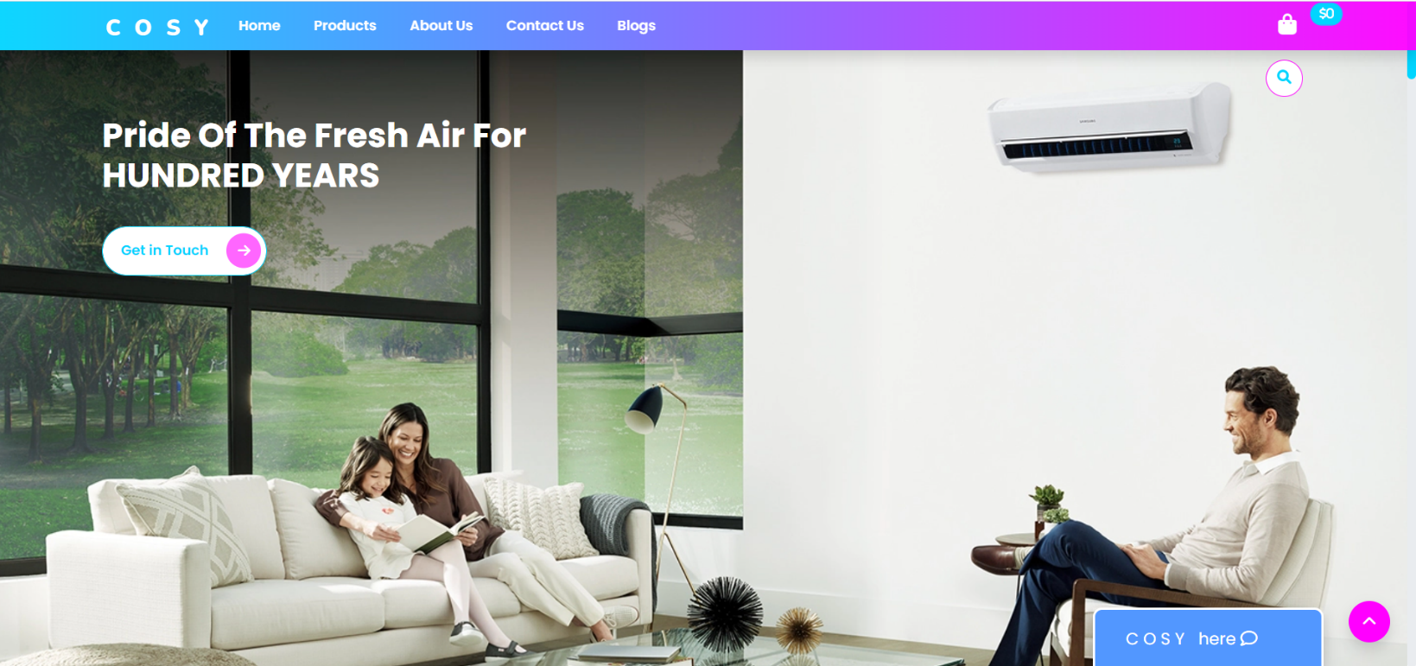

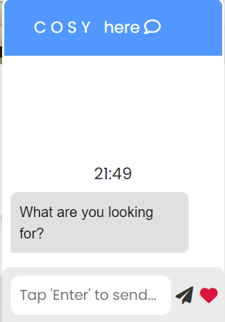

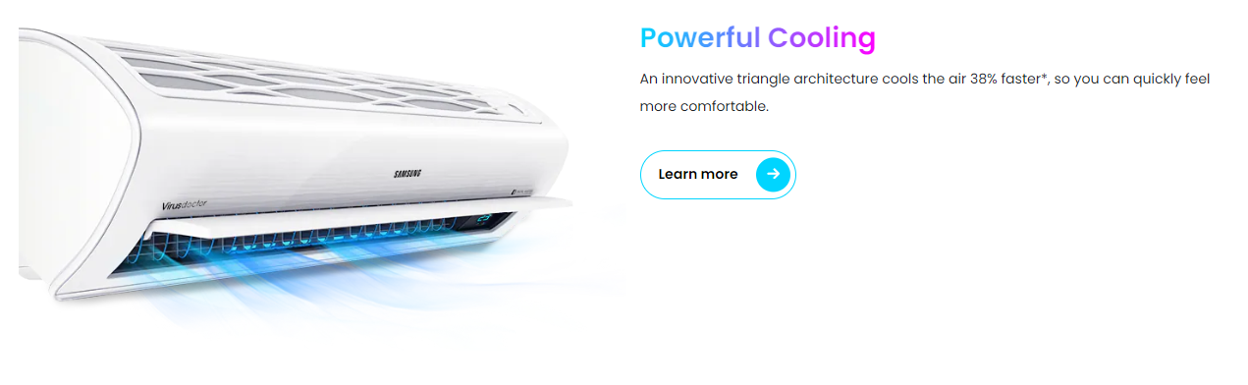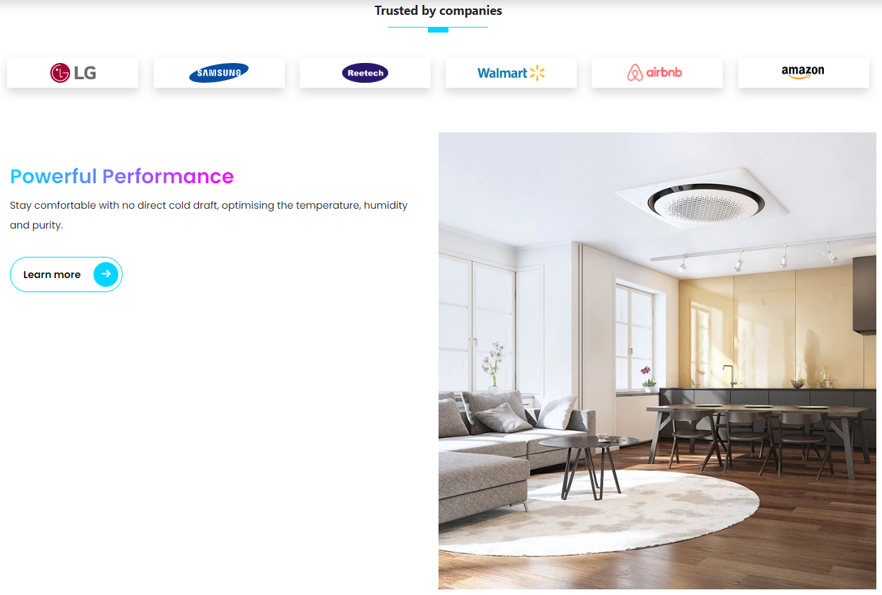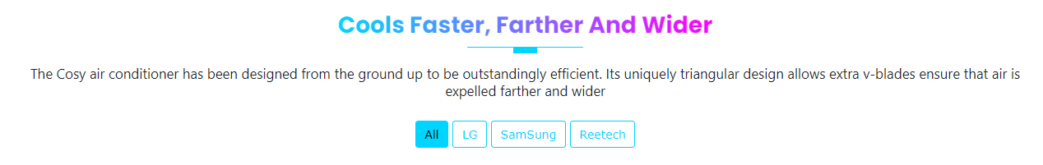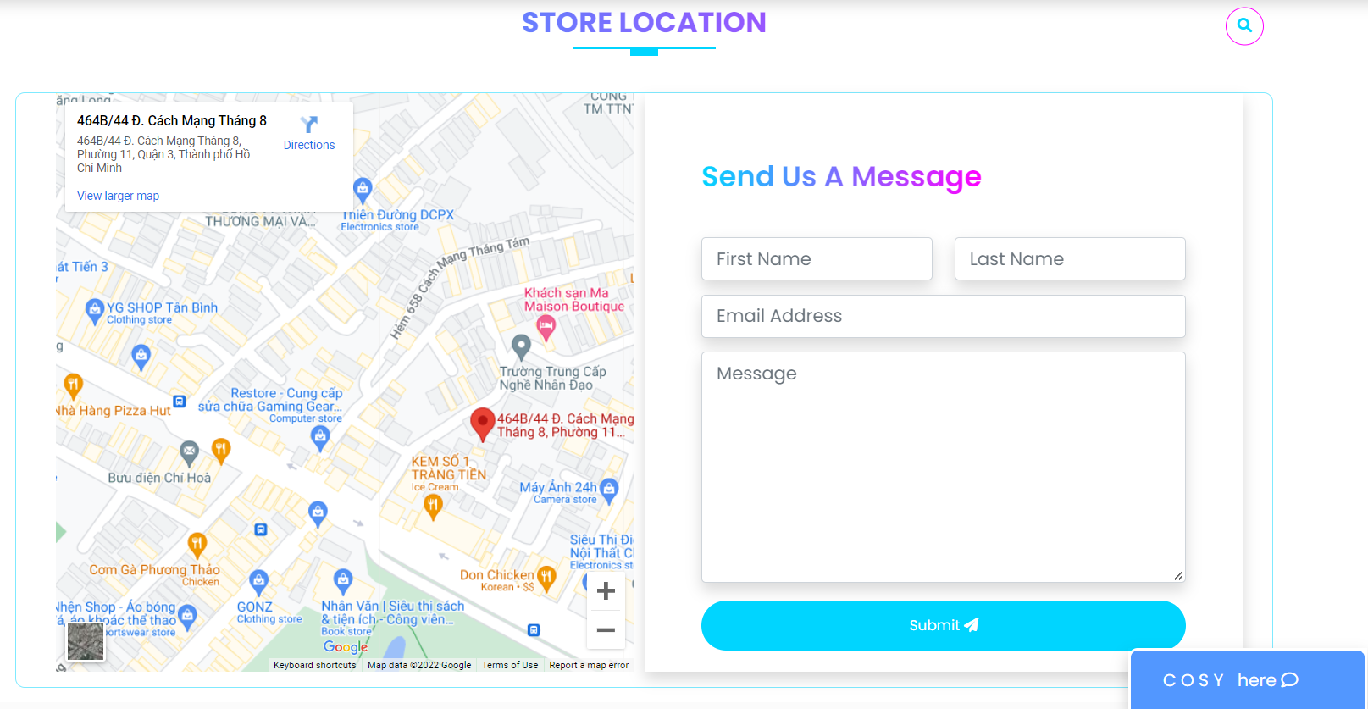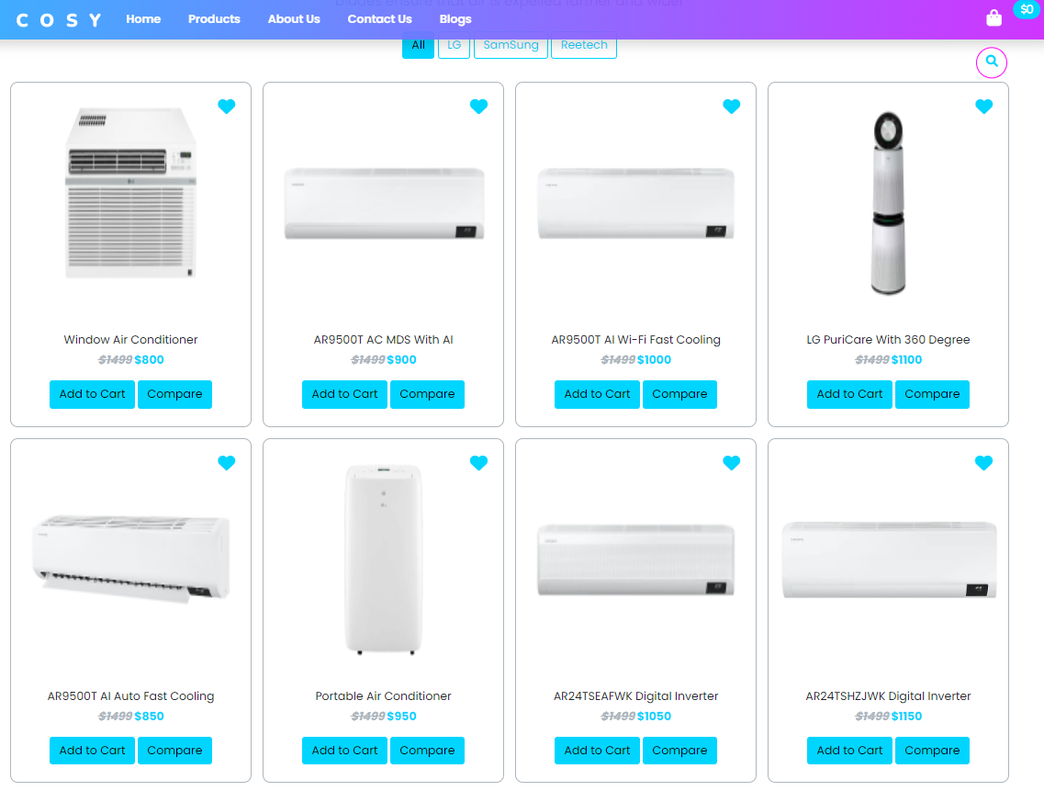

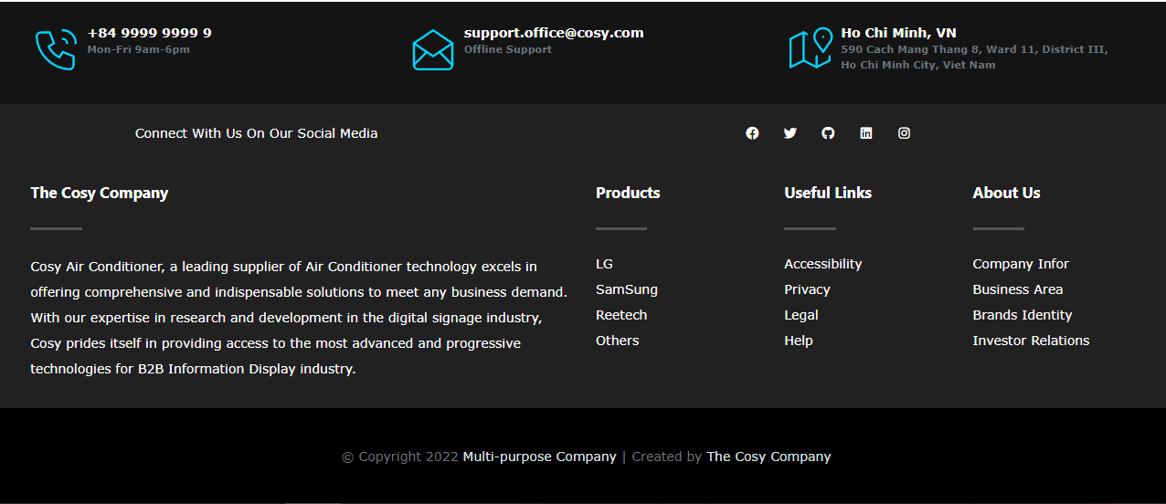

1. 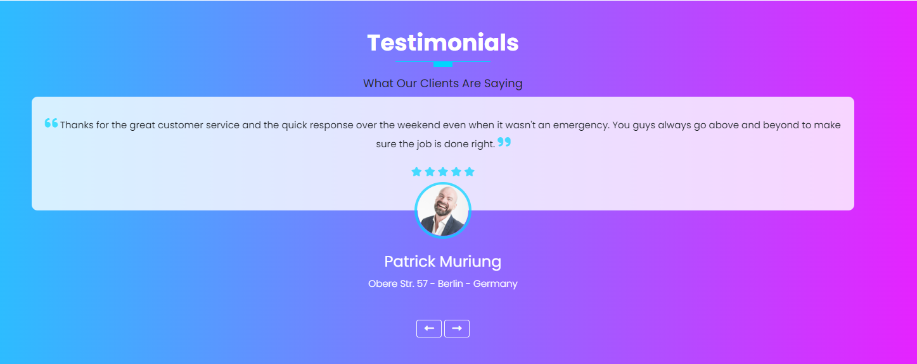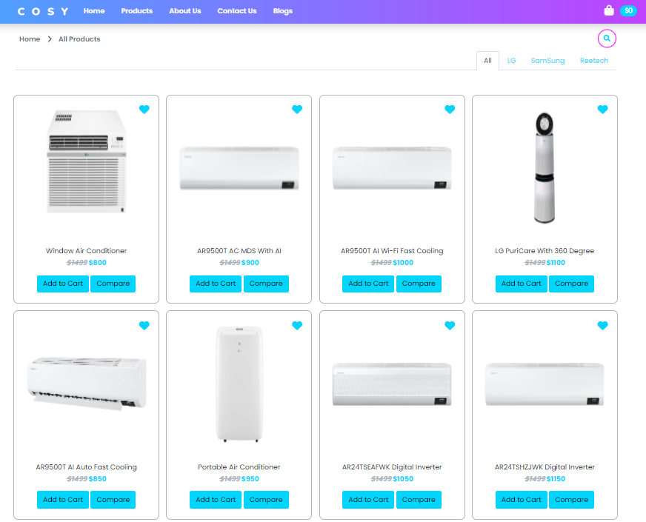**Product**



1. 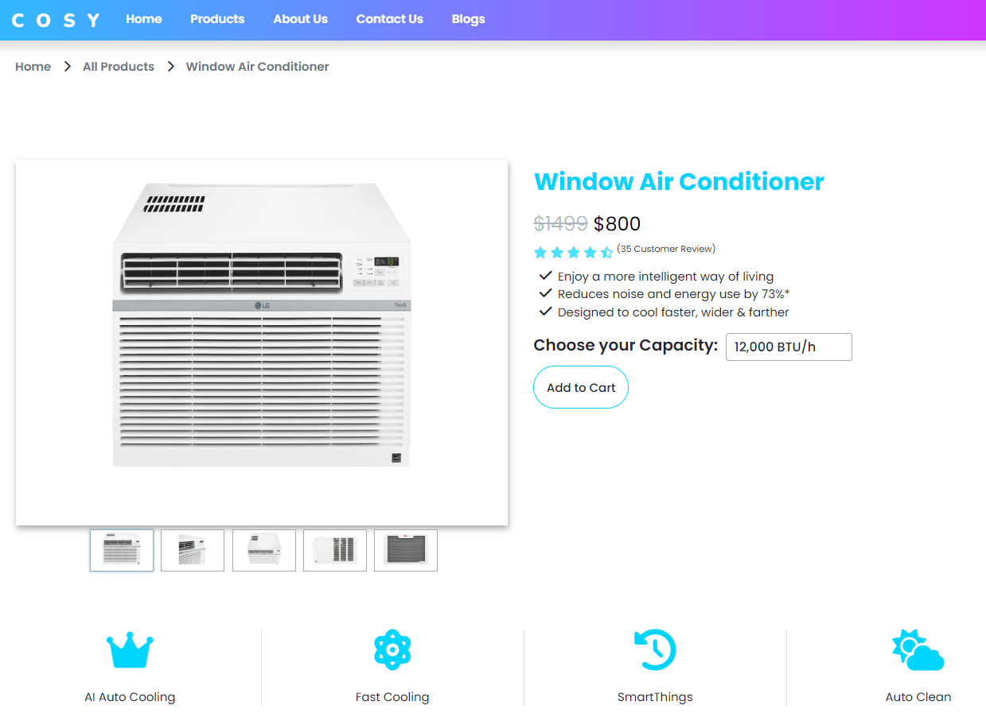**Product details**

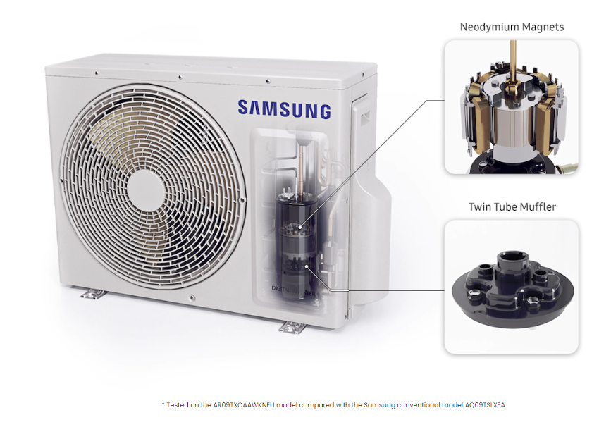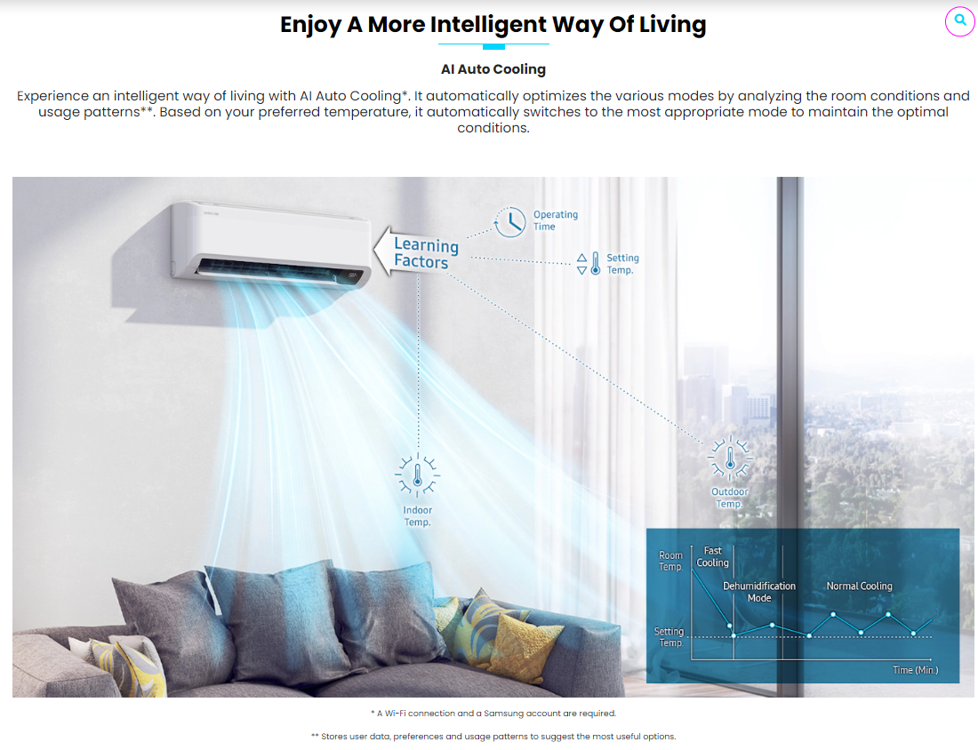

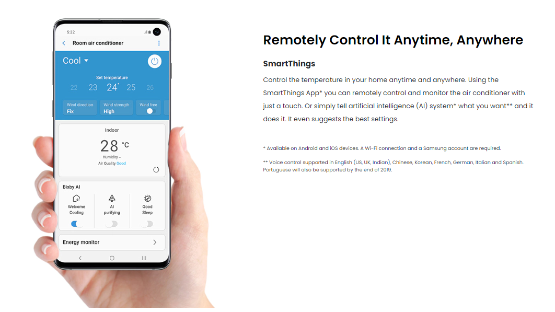

1. **Product comparison**

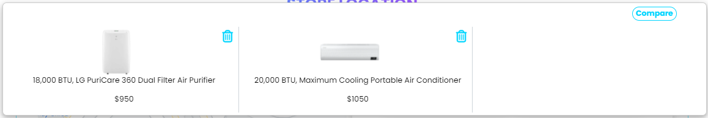

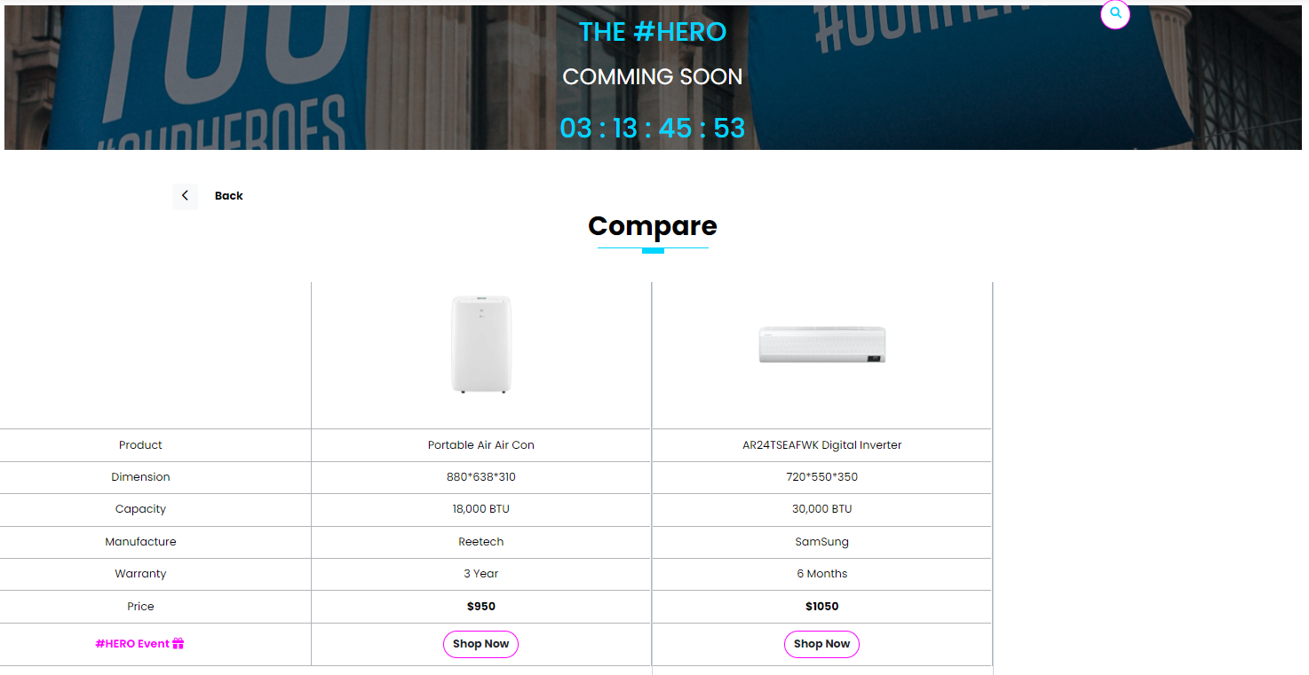

1. 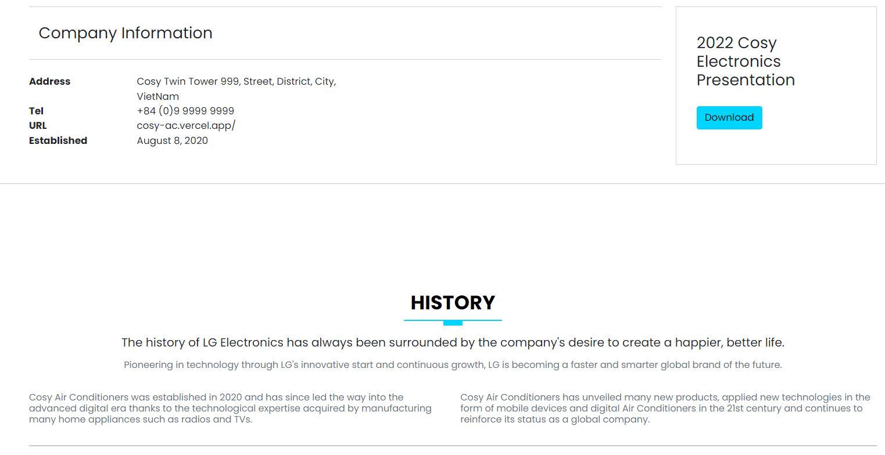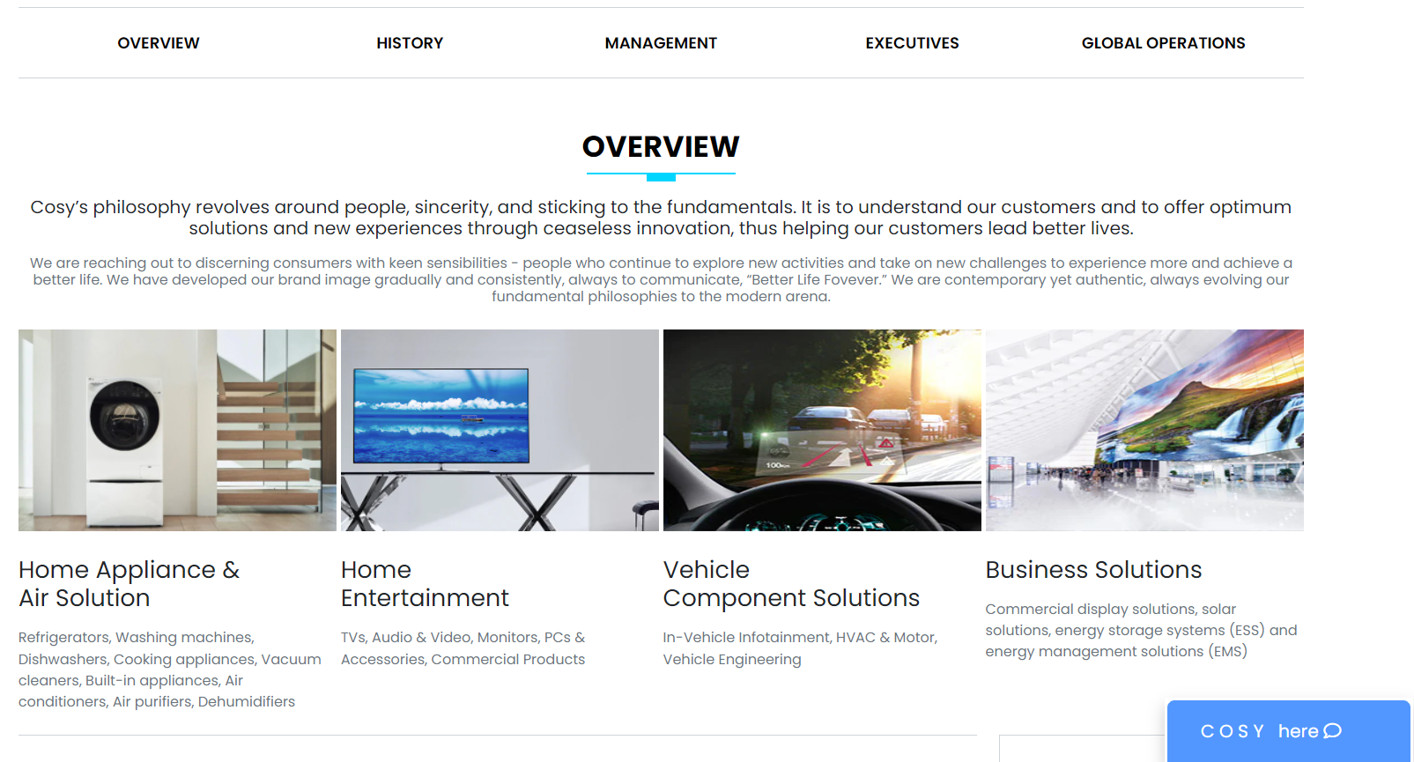**About us**

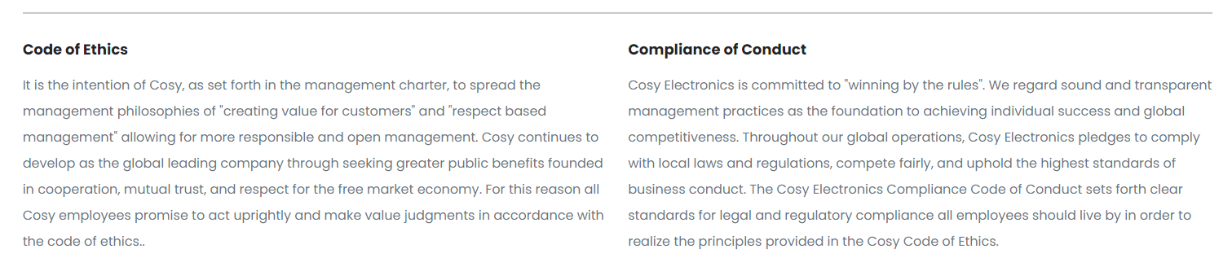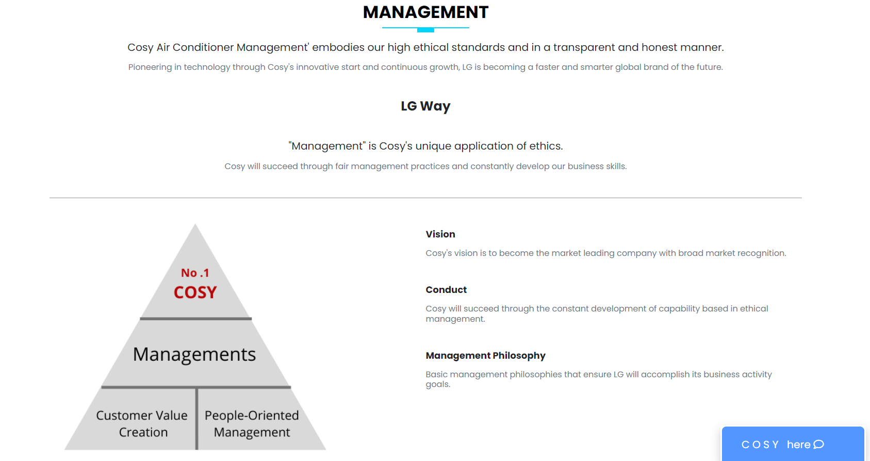

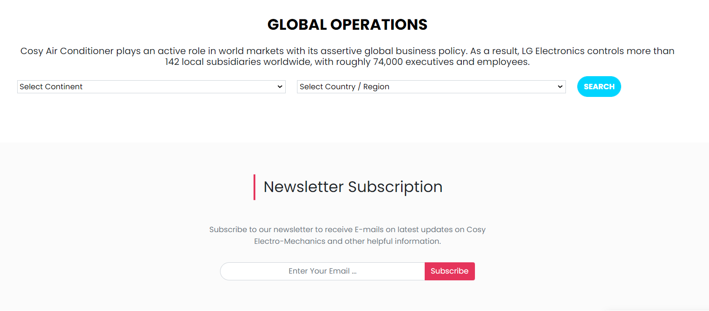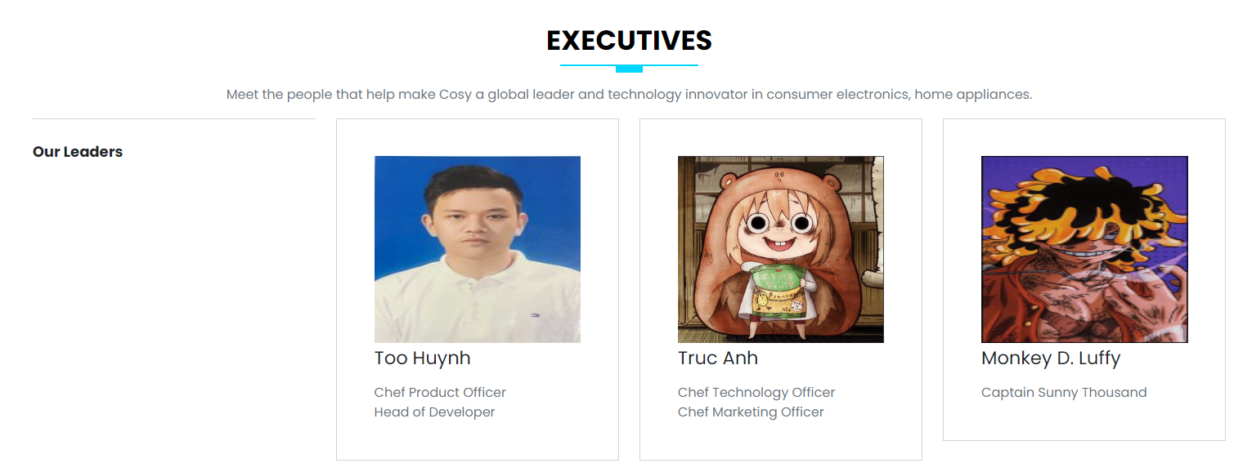

1. 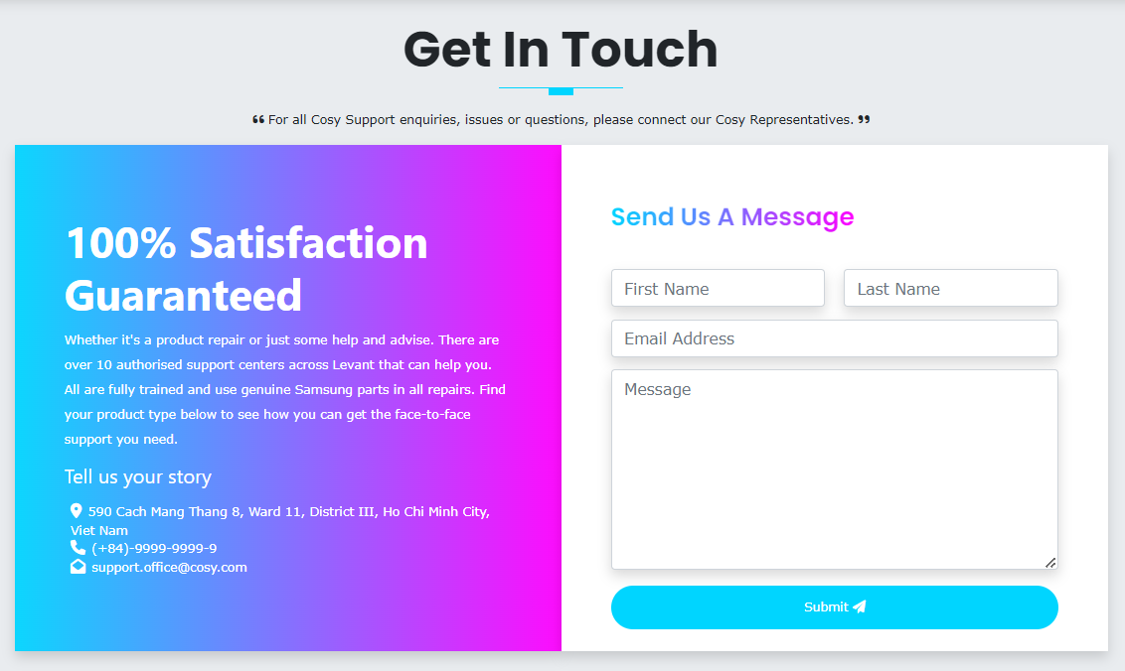**Contact Us**
2. 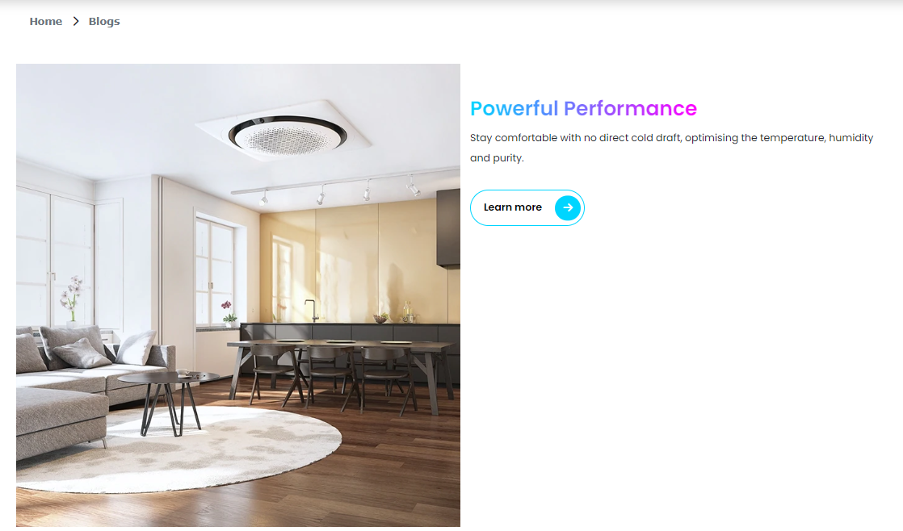**Blog**

**REVIEW 2 – TASK SHEET**

|  |  |  |  |  |  |  |
| --- | --- | --- | --- | --- | --- | --- |
| **Project Ref No.** | **Project title –**  **COSY Air-conditioner** | **Activity Plan Prepared by** | **Date of preparation of Activity plan** | | | |
| **Task** | **Actual Start Date** | **Actual Days** | **Teammate Name** | **Status** |
| Design & Build Homepage | |  |  |  | Thanh Tú, Hoàng Chương, Trúc Anh | Completed |
| Design & Build Contact Homepage | |  |  |  | Thanh Tú, Hoàng Chương, Trúc Anh | Completed |
| Design & Build About us page | |  |  |  | Thanh Tú, Hoàng Chương, Trúc Anh | Completed |
| Design & Build Footer Section | |  |  |  | Thanh Tú, Hoàng Chương, Trúc Anh | Completed |
| Design & Build Product Main page | |  |  |  | Thanh Tú, Hoàng Chương, Trúc Anh | Completed |
| Design & Build Product Detail page | |  |  |  | Thanh Tú, Hoàng Chương, Trúc Anh | Completed |
| Design & Build Product comparation | |  |  |  | Thanh Tú, Hoàng Chương, Trúc Anh | Completed |
| Design & Build Blog | |  |  |  | Thanh Tú, Hoàng Chương, Trúc Anh | Completed |
| Write Project Report | |  |  |  | Thanh Tú, Hoàng Chương, Trúc Anh | Completed |

**TESTING DOCUMENT**

|  |  |  |
| --- | --- | --- |
| **No** | **Features Tested** | **Remarks** |
| 1 | Are all the users able to view the images and links? | OK |
| 2 | Have all the views, modules and controllers been properly integrated and is the site function as a single page application? | OK |
| 3 | Are the GUI content devoid of spelling mistakes? | OK |
| 4 | Is the application user-friendly? | OK |
| 5 | Are all the forms validated with proper criteria? | OK |
| 6 | Do all text links lead to the appropriate website? | OK |
| 7 | Do all image links lead to the appropriate website? | OK |
| 8 | Are all the images and links clearly visible on the page? | OK |
| 9 | Is the Website launching correctly in all popular browsers? | OK |
| 10 | Does the Web page work properly in all the tested browsers? | OK |
| 11 | Does the Web page take too long to be loaded fully? | OK |
| 12 | Is the navigation sequences correct through all the Web pages on the site? | OK |
| 13 | Is the JavaScript code working as expected in all click events? | OK |

**FINAL CHECKLIST**

|  |  |  |
| --- | --- | --- |
| **No** | **Features Tested** | **Remarks** |
| 1 | Are all the users able to view the images and links? | OK |
| 2 | Have all the views, modules and controllers been properly integrated and is the site function as a single page application? | OK |
| 3 | Are the GUI content devoid of spelling mistakes? | OK |
| 4 | Is the application user-friendly? | OK |
| 5 | Is the Website launching correctly in all popular browsers? | OK |
| 6 | Are all the forms validated with proper criteria? | OK |
| 7 | Do all text links lead to the appropriate website? | OK |
| 8 | Do all image links lead to the appropriate website? | OK |
| 9 | Are all the images and links clearly visible on the page? | OK |
| 10 | Does the Web page work properly in all the tested browsers? | OK |
| 11 | Does the Web page take too long to be loaded fully? | OK |
| 12 | Is the navigation sequences correct through all the Web pages on the site? | OK |
| 13 | Is the JavaScript code working as expected in all click events? | OK |